THALES Software Systems Shanghai (TSSS)
Thales Software Systems (Shanghai) Co., Ltd
Company Profile
With operations in 60 countries and 70,000 high-caliber employees, Thales is a world-wide leader serving Aerospace, Defense and Security markets. Thales is especially renowned as an innovator and a leading technology provider involving dynamically in international R&D programmes, with its 22,000 engineers and researchers of its global network. The company invests 20% of annual revenues in R&D areas, including intelligent transport systems and critical information systems, where the highest level of performance and reliability is paramount.
In the domain of transportation and applied information systems, Thales delivers a unique range of solutions and services to meet the global needs of air, road and rail networks for both urban areas and the countryside.
Created in 2000, Thales Software Systems (Shanghai), known also as TSSS, is part of Thales’ China Integration Centre along with two other sister units: Thales Transportation Systems in Hong Kong and Thales Panda Transportation Systems in Nanjing.
TSSS is a strategic platform of Thales Group in system development and/or project prime contracting for a wide sphere of security-critical information systems, ranging from Ground transportation, Aerospace avionics, to IT security solutions, etc.
In terms of Ground transportation, TSSS has a strong technological portfolio in:
- Advanced Intelligent Transportation Systems & Services (Fleet management, Transit Signal Priority solutions, Parking Management solutions, Traffic Information Plat-form, etc.)
- Security-critical systems for rail network (Rail Signaling systems, Control and Supervision system, etc.)
- Security-critical systems for urban metro and light rail network (Automatic Fare Collection systems, Metro Signaling system, Control and Supervision system, etc.)
Through important R&D investment, TSSS has been endeavoring to better satisfy Chinese local customers by artful implementation of cutting-edges technologies of Thales. We have successful implementation in multiple Chinese major cities including Beijing, Shanghai, Nanjing, Shenzhen, Guangzhou and also some Asian cities such as Hong Kong, Taipei, New Delhi, Bangkok, Mumbai, etc.
As an initial partner in the framework of a series of Sino-French cooperation programmes in ITS since 2002, at the very beginning of these actions, TSSS has been contributing to the promotion of European ITS in China while perfecting our understanding of local customers’ practical needs and China market evolution. TSSS is today appreciated by local authorities and institutions as a reliable partner.
Please also refer to our corporate website (www.thalesgroup.com) for more information of Thales’ global activities in Aerospace, Defense and Security markets and its presence in China and Asia.

Profile of staff members

Dr. Serge DRUAIS – Thales Asia Researh & Technology Director
Dr. Serge Druais, graduate from the Ecole Polytechnique in France and PhD in computer science, joined Thales in 1989 as IT project leader. In 1999, he was appointed CIO for the Thales Group. In 2005, as Innovation Director, he helped Thales to expand R&D activities at European level and played an active role in setting up the NESSI European Technology platforms, as a recognized expert in the fields of software and services.
In 2006, Serge DRUAIS created ThereSIS (in Ecole Polytechnique campus), a Thales laboratory dedicated to innovation and complex system engineering.
Now based in Shanghai he is responsible of the development of R&T in Asia (China, Singapore, India, Japan and Korea) and to coordinate actions in ICT at the worldwide level.

Fanlu KONG – Business Development Manager
Fanlu KONG joined Thales Software Systems (Shanghai) in 2007 as a Business
Manager. He is currently in charge of marketing and strategies for Transport, Security and Oil&Gas businesses. He is also responsible of pre-sales and project management for ITS-related projects of the company.
Fanlu KONG holds a Master Degree in Transportation from Tongji University of Shanghai, and a French Master diploma in Intelligent Transportation Systems from the Ecole Nationale des Ponts et Chaussées. He is currently an undergraduate EMBA student in Shanghai JiaoTong University.

Photos Gallery

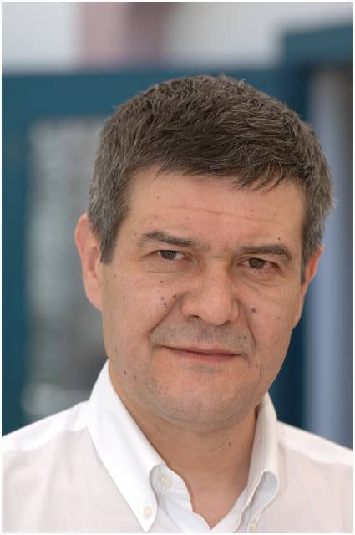 | 
Serge DRUAIS | Fanlu KONG
Serge.druais@asia.thalesgroup.com | Fanlu.komg@asia.thalesgroup.com
+86 15000 55 65 75 | +86 13472874575

